Relationship Between Temperature and Beverages:

A Comparative Study

Prerana Adhikari and Prajita Niraula

STATS-310, Grinnell College

**Abstract**

*Globalization has enabled large-scale companies to enter markets beyond their home-countries and, thus, have given them a plethora of opportunities to earn more profit. But, entering a new country has been marked by the challenges of adopting a product based on the local culture. Time and time again, the success and failure stories of Multi-National Companies have highlighted the role of culture in shaping consumer’s preferences for a product. However, is it possible for a universal preference for a specific characteristic—if not a product—regardless of the cultural preferences? Since, basic human anatomy is similar, any preferences shaped by the human mechanism should be the same. Therefore, we tested for a characteristic—beverage temperature—that had empirical evidences of conflicting cultural preference and preference backed by scientific studies. To elaborate, common knowledge suggests that human prefer cold drinks during the hot weather and hot drinks during the cold weather. However, in certain parts of China and South India, people generally prefer hot or warm drinks even during hot summer. So, the experiment tested the change in the comfort level and change in the happiness level while drinking beverages as per cultural preferences—measured by self-reported beverage temperature preference—and as per the weather. If the subject tested were happier when they drink beverage as per the weather, then, there would be a chance for a universal preference for product. Therefore, if there were any significant findings, Multi-National Beverages Companies would have used the result for the product development while entering a new market. Unfortunately, the data collected failed to get any statistically significant findings. However, the lack of significant result might be the fault of the experimental design rather than the lack of the relationship between the variables being studied. Hence, we suggest this experiment to be replicated using a better and bigger sample.*

Relationship Between Temperature And Beverages: A Comparative Study

Globalization and International Trade go hand in hand. The relation between the two is quite simple: Trade fosters interdependency among countries and, thus, promotes globalization and, in turn, globalization supports trade by allowing new markets. Therefore, it is no surprise that the ‘first wave for globalization’ and the growth in world trade, which was triggered by technological advances, both started simultaneously during the 19th century. ( Ortiz-Ospina, Beltekian, & Roser, 2018). Though there are different pros and cons, and winners, and losers of globalization, there is no denying that one of the biggest winners of globalization are the Multinational Corporation (MNC). Investopedia describes Multinational Corporation as a corporate organization which operates in more than one country. As big companies saturate the market in their home countries, globalization provides the opportunity to enter a new market to earn profits.

However, discovering a new market does not always translate to success. One of the reasons big companies that are efficient in one market fail to achieve similar success in another because the strategies that work in one market does not always work well in other countries due to the cultural difference. For example, when the big box chain—Best Buy—tried to enter the European market in 2011, the company could not make any significant impact in the market because it failed to notice that the Europeans prefer smaller shops to large box stores (*10 Successful American Businesses That Have Failed Overseas*, 2013). Hence, understanding the role of culture in shaping consumer’s behavior, a lot of Multinational Corporation subscribe to the following saying: *Think Globally, Act Locally*.

**The Philosophy of “*Think Globally, Act Locally*”**

In the business world, the “*Think Globally, Act Locally*” suggests that a company should aim for global operation but should also try to adopt its products or services according to the local culture while entering any new market. For example, McDonald curates its menu based on the local preference. Instead of selling same kind of burgers in different countries, McDonald created McItaly burger in Italy, Maharaja Mac in India. Not only McDonalds but other companies such as Starbucks, Hindustan Lever Limited (HLL), Ford, and Subway to name few, have gained profit by adopting their products and services to the local culture.

**The Big Question—is a universal preference for a product characteristic probable?**

As discussed in the previous section, culture plays an important role in shaping consumer’s preferences. However, is there a possibility for a universal preference for a product characteristic? Motivated by this question, we tried to test whether there ever could be a universal preference for a product’s preference. Since the basic human anatomy, the organ system, and mechanism is universal, any preferences that are guided by the anatomical regulation should be universal.

After brainstorming, the preference for a beverage’s temperature was chosen as the topic of study. A beverage’s temperature was selected for two specific reasons. Firstly, there were evidences of competing claims between preferences as per scientific reasoning and preference as per culture. Common knowledge suggests that people prefer hot drinks during cold weather and cold drinks during hot weather. When body is heated, drinking cold water is known to decrease the body temperature (Khamnei, Zamanlu, & Hosseinlou, 2011) Therefore, American College of Sports Medicine recommends that ingested fluids be cooler than ambient temperature, between 15 degrees and 22 degrees C (Convertino et al., [1996](https://www.ncbi.nlm.nih.gov/pmc/articles/PMC3761501/#ref5)). However, in certain parts of the world like South India (Sengupta, 2018) and China (Deason, 2017), people prefer hot or warm drinks even during the blazing hot summer. According to a study conducted at University of Ottawa’s School of Human Kinetics, drinking hot beverages in hot summer reduces body temperature only in dry location, but not a humid one. (Bain, Lesperance, Jay, 2012)The study posited that for hot beverages to work during summer, the body has to compensate for the increased body temperature from the drinks by increasing the perspiration rate. If the air is dry, then, sweat evaporates more easily so the body must increase its perspiration rate to regulate the body temperature. But in a humid climate, the rate of perspiration is not high enough to decrease the body temperature with hot beverages. Interestingly, South India is a coastal region, so it has a humid climate. Similarly, Beijing also has humid summer. Therefore, testing for whether change in the happiness and comfort level is higher when drinking beverages as per anatomical regulation than the change in the level when drinking as per culture could aid Multinational Beverage Companies to make better business decision. To elaborate, if the results of the experiment had found that the change in comfort level for drinking beverages was higher when drinking beverages as per the scientific reasoning, then, those companies would benefit from introducing new beverages in the previous mentioned countries that have scientific backings and eventually reshape their preferences.

Secondly, manipulating beverage to conduct the experiment was feasible. Additionally, the sporadic weather change in Iowa allowed us to conduct the experiment for both the hot day and the cold day treatment level.

The experiment tested the change in the happiness level and the change in the comfort level when the participants drank water as per their cultural preference—measured by self-reported beverage temperature preference—and as per the weather. By comparing the difference between the change in the comfort level and the happiness level, the experiment hoped to answer whether or not a universal preference for a product characteristic is probable or not. We hypothesized that “*if culture has more impact on the subject’s comfort and happiness, the reported positive change in comfort and happiness level will be higher when they drink water as per their preference.*”

**Method**

**Participants**

A sample size of 24 (representative of Grinnell College) participated in the experiment. Students either in the vicinity of the Grill or Statistics lab were asked to be the subjects of the experiment. However, picking a sample based on feasibility threatened the external validity of the study as the sample was not correct presentation of the true population.

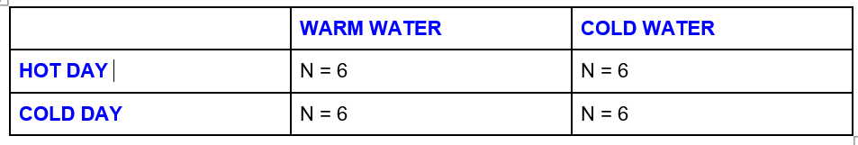

*Table 1:* Distribution of the participants

**Materials**

For this experiment, temperature was manipulated in two different categories by using hot water, filter water, and ice. For a cold cup of water, ice was poured on half a cup of normal filter water. For a cup of warm water, half a cup of filter water was mixed with half a cup of hot water. The type of cup given to each participant was documented using the questions on pre-experimental form. The experiment used water, instead of other beverages to control for any variability in the data caused by the taste preferences. Similarly, iOS Weather app was to pick a hot day and a cold day. The day-time when the temperature was around 60oF was chosen for the hot day and the day-time when the average temperature was around 40oF was chosen for the cold day.

The pre-experimental and post-experimental form to primarily measure the change in the happiness level and the comfort level. The pre-experimental form consisted of general personal questions like class year, and age. Additionally, the pre-experimental form also asked the participants to choose between their favorite drink: hot or warm. This self-reported preferences was used as a way to measure the cultural preferences since taste preferences are influenced by cultural forces through repeated exposure, and influencing dietary choices of a breast feeding mother (Feunekes et al., 1998). Lastly, the pre-experimental form also asked the participants to rate their happiness and comfort level based from 1 to 5 such that 1 was the lowest reported levels and 5 was the highest reported level for both the variables. The full form can be viewed through this link: <https://bit.ly/2WFk8tu> . Similarly, the post-experimental form also asked the rate their happiness and comfort level based from 1 to 5. Additionally, the form also asked for the participant’s reaction to the “neutral video”. The full form can be viewed through this link: <https://bit.ly/2VllWpV>.

**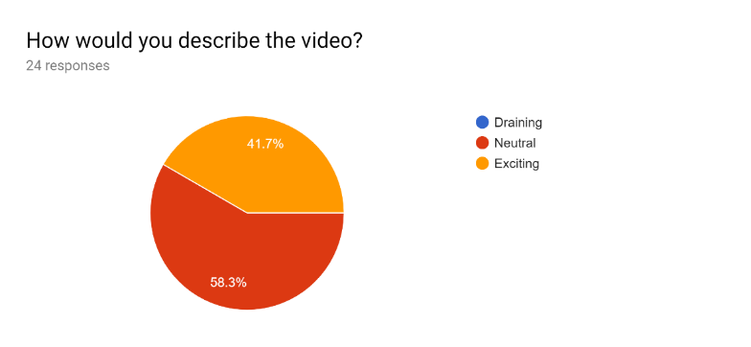**A 5-minutes long neutral video (<https://bit.ly/2HwhteP> ) of birds flying was used as a time filler during the experiment. The purpose of a neutral filler video was to control for the mood change in the participants that might result from sitting idly while the experiment is being conducted. Over half of the participants reported the video as neutral, and none reported the video as draining. However, in the post-experimental form, 41.7% of the participants found the video exciting (Fig. 1).

*Fig. 1*: Pie chart showing the distribution of the participant’s reaction to the video

| **Source** | **DF** | **Sum of Squares** | **Mean Square** | **F Value** | **Pr > F** |
| --- | --- | --- | --- | --- | --- |
| **Model** | 1 | 1.23106061 | 1.23106061 | 1.45 | 0.2419 |
| **Error** | 22 | 18.72727273 | 0.85123967 |  |  |
| **Corrected Total** | 23 | 19.95833333 |  |  |  |

the video shown

| **Source** | **DF** | **Sum of Squares** | **Mean Square** | **F Value** | **Pr > F** |
| --- | --- | --- | --- | --- | --- |
| **Model** | 1 | 2.68 | 2.68 | 4.44 | 0.0468 |
| **Error** | 22 | 13.31 | 0.60 |  |  |
| **Corrected Total** | 23 | 16.00 |  |  |  |

| **Source** | **DF** | **Sum of Squares** | **Mean Square** | **F Value** | **Pr > F** |
| --- | --- | --- | --- | --- | --- |
| **Model** | 1 | 1.23 | 1.23 | 1.45 | 0.2419 |
| **Error** | 22 | 18.72 | 0.85 |  |  |
| **Corrected Total** | 23 | 19.95 |  |  |  |

An ANOVA test was conducted to investigate any confounding effect on the variables begin studied. The ANOVA test revealed that the different reactions had no effect on the change in the happiness level (Table 3; *p>.05*). Unfortunately, the reaction to the video affected the change in the comfort level (Table 2; *p<.05)*.

*Table 3*: Reported ANOVA Result for the effect of change of the reaction to the video on the change in the happiness level

*Table 2*: Reported ANOVA Result for the effect of the reaction to the video on the change in the comfort level

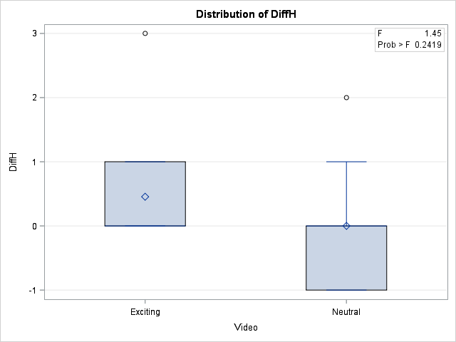 The participants who found the video exciting, reported higher level of change in the comfort level on average (Fig. 2). Therefore, there is a chance that the choice of the video threatened the internal validity in the case of the change in the comfort level.

*Fig. 2*: Box-plot showing the distribution of happiness level among participants who found the video neutral and exciting

**Procedure**

First, a hot day and a cold day was chosen with the help with of the iOS Weather App. For each day, 6 hot drinks and 6 cold drinks were randomly assigned to the participants. We did not know who were participating before the experiment began. Therefore, for each day, the first person to join the experiment was Participant 1, the second person was Participant 2 and so on and so forth. The day before the experiment was conducted, random assignment was done for each participant number. This random assignment was done using an algorithm that randomly assigned each participant a number. There were 6 odd numbered participants and 6 even numbered participants for each day. All the odd participants were given cold drink and the remaining were assigned warm drink. After the drink was assigned, the participant filled the pre-experiment form. Then, the participants were asked to watch a video while drinking their beverage. After video was over, the participants were asked to fill out the post-experiment form. This process was repeated until we had 24 participants all together.

*Fig. 3*: Box-plot showing the distribution of happiness level among participants who found the video neutral and exciting

**Results**

Two-way ANOVA was used to analyze the data. Unfortunately, there were so significant findings for both change in the comfort level (Table 4;*p > .05*) and the change in the happiness level (Table 5; *p > .05*).

Though there were signs of lack of both normality and homogeneity, ANOVA is robust against such violation of assumptions. Therefore, the insignificant findings could have been result of the experimental design and the sample instead.

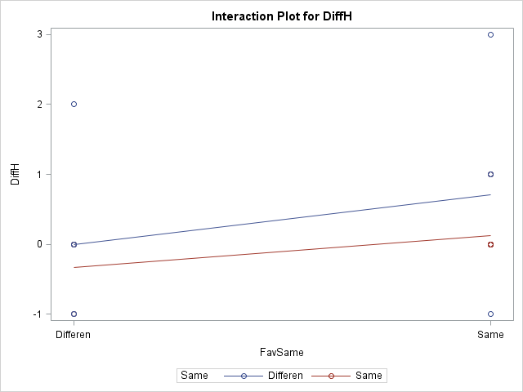 However, the data showed an interesting interaction—although this interaction was insignificant. The change in the happiness level was higher when the temperature of the drink was different from the weather and when the temperature of the drink matched the preferred drink. Over all, there was an average negative change in the happiness level when the temperature did not match the preferred temperature and when the temperature of the weather matched the temperature of the drink. These findings and the preferences were in align with the previous literatures on preference for the temperature of the beverages that are the opposite of the weather. Unsurprisingly, the highest change in happiness was reported when the drink matched both the weather preference and the cultural preference and lowest in the opposite case.

*Fig. 4:* Interaction Plot for preference as per favorite drink (FavSame) divided into drink same as the preferred drink and different from the preferred drink, and temperature of drink and the weather (Same) divided into the temperature of drink same to the temperature of the weather and different from the weather. DiffH referring to Change in the Happiness.

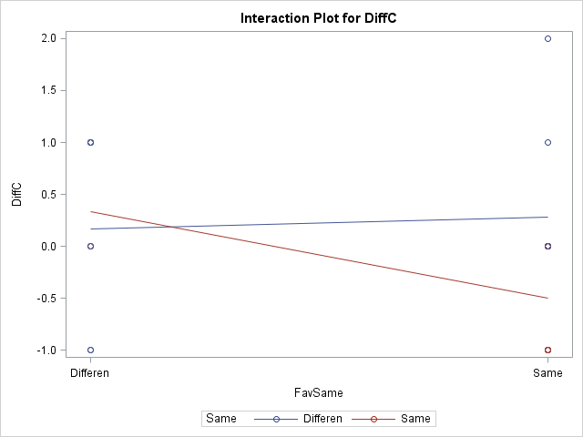 For the change in the comfort level however, the reported change in comfort when the drink matched the preference and when the beverage temperature matched the weather was the lowest. We had expected the lowest change in the comfort level to be when both the weather preference and the cultural preference were unsatisfactory, which is when the beverage temperature is similar to the weather temperature but opposite to the preferred beverage temperature. On possible reason for this unexpected finding could be the effect of a compounding variable (reaction to the video) reported in Table 3.

*Fig. 5*: *Fig. 4:* Interaction Plot for preference as per favorite drink (FavSame) divided into drink same as the preferred drink and different from the preferred drink, and temperature of drink and the weather (Same) divided into the temperature of drink same to the temperature of the weather and different from the weather. DiffC referring to Change in the Comfort Level.

**Discussion**

As stated earlier in the result section, our experiment failed to find any significant findings. The data could not find any significant effect of drinking as per climate and as per culture on the change in the happiness and the comfort level. Since, we failed to find significant effect of both drinking as per climate and as per culture, the experiment could not give any conclusive answer to the question posited earlier in the paper about chances of a universal preference. To elaborate, since drinking as per weather is insignificant the answer for universal preference for beverage temperature should be no. But the data also did not find any significant change for cultural preference, so the answer for the universal preference for beverage temperature could be also yes. This inconclusive result from the experiment could be, however, due to the fault in the experimental design rather than the absence of the relationships being studied. Like stated in the earlier sections, the lack of randomization for sample selection threatened the external validity. Similarly, the statistically significant effect of the participant’s reaction as exciting on the change in the comfort level threatened the internal validity of the experiment. Therefore, the insignificant findings of this experiment could be result of the experimental design flaws, instead of the absence of the relationship being studied. Lastly, there is also a chance that the personal preference is not the perfect representation of the cultural preferences—which again risked the internal validity of the experiment.

Regardless of the results, this experiment still asks an interesting question whose answer could be used in product development for the beverage industry. Additionally, the experiment observed an interesting interaction: the average change in happiness was highest when the temperature of the drink was different from the weather and also matched the preferred drink. However, this interaction was statistically insignificant. Maybe replicating this experiment with a better design might find this interaction significant and also find a conclusive result.

Therefore, for future replication of this experiment, we suggest using randomization for sample selection to avoid sample bias. Additionally, additional precaution should be taken for choosing the neutral video. Lastly, if possible, developing a better measure for the cultural preference might help find a conclusive experiment.

**References:**

10 Successful American Businesses That Have Failed Overseas. (2013, September 12). Retrieved from <https://www.internationalbusinessguide.org/10-successful-american-businesses-that-have-failed-overseas/>

Bain AR, Lesperance NC, Jay O. Body heat storage during physical activity is lower with hot fluid ingestion under conditions that permit full evaporation. Acta Physiol (Oxf) 2012;206:98-108. 10.1111/j.1748-1716.2012.02452.x [[PubMed](https://www.ncbi.nlm.nih.gov/pubmed/22574769)] [[CrossRef](https://dx.doi.org/10.1111%2Fj.1748-1716.2012.02452.x" \t "pmc_ext)] [[Google Scholar](https://scholar.google.com/scholar_lookup?journal=Acta+Physiol+(Oxf)&title=Body+heat+storage+during+physical+activity+is+lower+with+hot+fluid+ingestion+under+conditions+that+permit+full+evaporation&author=AR+Bain&author=NC+Lesperance&author=O+Jay&volume=206&publication_year=2012&pages=98-108&pmid=22574769&doi=10.1111/j.1748-1716.2012.02452.x&)]

Deason, R. (2017, December 23). Why Do Chinese People Drink Hot Water? Retrieved from <https://theculturetrip.com/asia/china/articles/why-do-chinese-people-drink-hot-water/>

Feunekes GIJ, et al. (1998). Food choice and fat intake of adolescents and adults: associations of intakes within social networks. Preventive Medicine 27:645-656

Khamnei, S., Zamanlu, M., & Hosseinlou, A. (2011). Water Temperature, Voluntary Drinking and Fluid Balance in Dehydrated Taekwondo Athletes. doi:10.3897/bdj.4.e7720.figure2f

Ortiz-Ospina, E., Beltekian, D., & Roser, M. (2018, October 29). Trade and Globalization. Retrieved from <https://ourworldindata.org/trade-and-globalization>

Sengupta, S. (2018, May 07). Why Do South Indians Drink Warm Water With And After Meals? Retrieved from <https://food.ndtv.com/food-drinks/why-do-south-indians-drink-warm-water-with-and-after-meals-1848371>